Model A Ford Club of America- Bakersfield Chapter
General Membership Meeting, April 7, 2025

The meeting was called to order by club president, Kirk Ritter at 6:51pm and led us in the flag salute. Happy Birthday to Mona Vipham, Rick Davis, Ali Dyess, Paul Jones, Susan Quarnberg, Chuck Parker, Simon Huff, Shelby Foulk and Gail Malouf. Happy Anniversary to Sharon and Woody Barr, Stan and Mary Nicks, Lou and Terry Marraccino and Ken and Susan Quarnberg.

Board Reports- Secretary- A motion was made by Ken Quarnberg to accept the minutes as written from our March 3, 2025, meeting. The motion was seconded by Kirk Ritter and approved by the attendants. Treasurer- There was a motion made by Debbie Launer to accept the treasurer’s report given by Sharon Davis. This was seconded by Larry Ray. The club accepted the report as read. Second Vice President- Dawn Collins delivered the notes this evening for Linda Jackson. April 17 is dinner and drive to Salty’s at 6:30. On April 19 we will be going on a wild flower tour. If you plan on attending, please meet at the Denny’s on Panama at 9:00am. If you have not signed up and wish to go, please let Dawn know so the group will wait for those going. After touring the flowers lunch will be at The Rockhouse. May 2-3 is a swap meet at Minter Field. There will be preferred parking for our club. The information about the event will be on the website. Also, May 3 is the Mile Long Swap and Car Show in Kernville. Register your car and you get a lunch ticket. May 10 is a Roaring 20’s themed birthday for Thelma Horn who is Linda’s mom and is turning 100! The party is being hosted by Linda. Dinner, dancing and live entertainment. Bring your Moel A and dress in 1920’s fashion. More details will be coming. On May 24 there is a fundraiser car show at Paula’s church. She will provide us with more information as the time gets
closer. Save the date for the Santa Maria Round Up on October 18. Hosted at the home of John Human, it is a great event, bringing clubs together. September 13 will be the All- Ford Car Show in Orcutt. Member at Large- Sam drew for vest worn and Linda Sheffield won. For driving your Model A to the meeting, the winner was Debbie Launer. For attendance the name pulled, Milton Morovich was not present, so the money rolls to next month.
CCRG- The CCRG in Visalia was a great event. 250 people were in attendance. There were tours both Friday and Saturday with a great bar-b-que on Friday night followed by the banquet on Saturday. There were plenty of great raffle prizes. It was announced that next year Bakersfield will be hosting the event. No MAFCA report this month. Sunshine Report- Linda Jackson is in the hospital. She felt ill in Visalia and ended up going to Urgent Care and was admitted to the hospital with pneumonia. She is recovering and we hope to see her soon. Jim Berry has been having some issues with low blood pressure and having an angiogram done. Keep him in your prayers.
If you need shirts Debbie Launer has some nice denim shirts with the club logo if you are interested. They are $37 without your name or $42 with. She also can order vests if you need them.
Old Business- Kirk reported on the Selma Swap. A lot of club members made the journey. Kirk ended up seeing his old car there and was able to talk to the guy that bought it and reminisce. Kirk enjoyed the visit with his “old friend.” Several members made the drive down to Orange County for the pancake breakfast. Richard Harger won lots of goodies and Susan Quarnberg won $100! Kirk also won a nice clock, so it sounded like a successful trip.
First Vice President- Dawn Collins filled in for Denise tonight. She went over the history of the CCRG, the Jamboree and all that that entails. She went over the details of the Visalia CCRG and the goings on and to remind everyone we will need everyone’s help to pull this off. We are a great club, and we will have a great CCRG. Dawn did a really nice job sharing all of this with us and it was very helpful and great for our new members.
The meeting was adjourned at 7:58. See you next month.

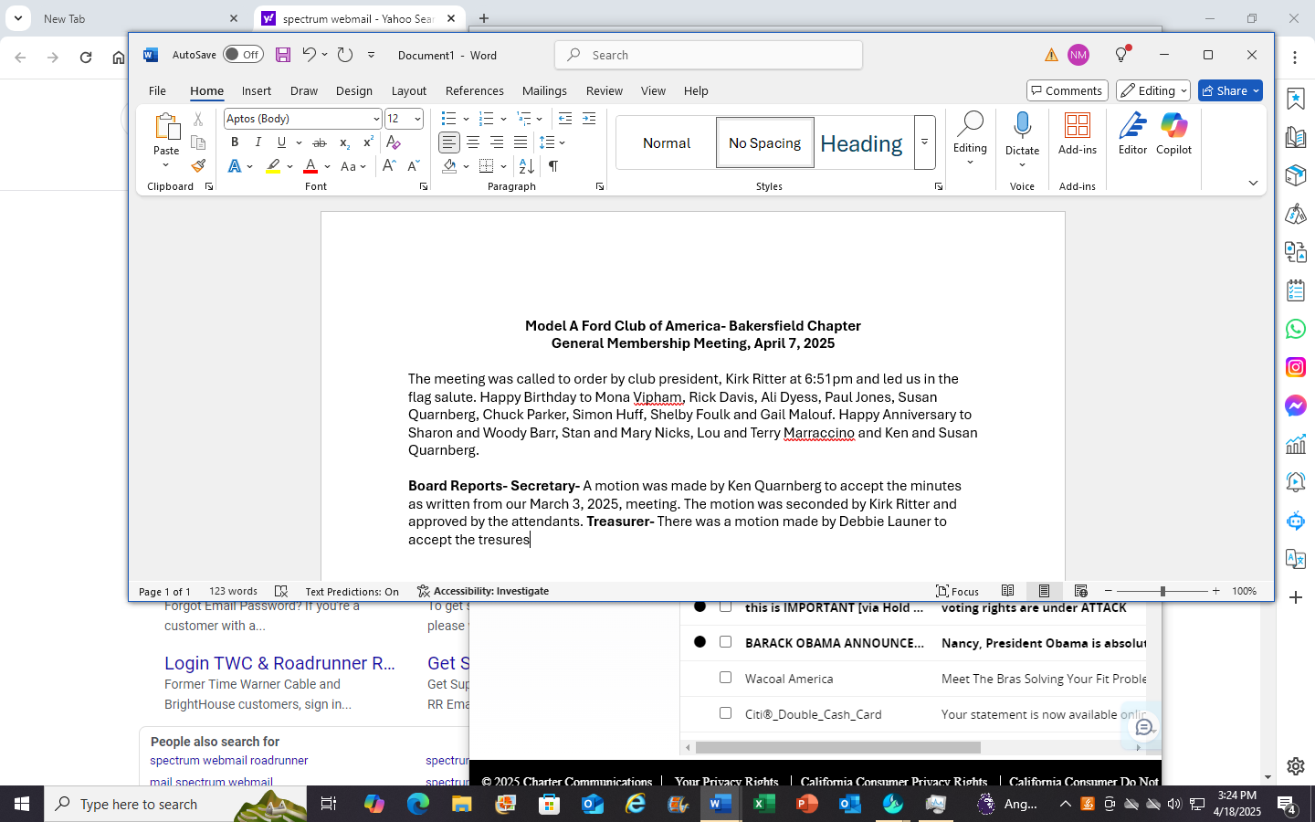:3

